27" Mac 17" Dual Core16 Gb Ram 500 GB HDD, Tenba Flight Case | 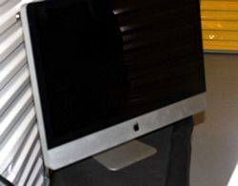 | x1
Canon XA20 HD Video Camera plus Flight Case | 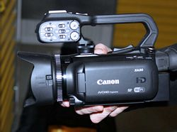 | x1
Kata LED Light | 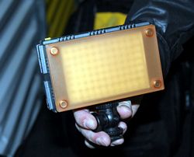 | x1
Da-Lite 6Ft x 4Ft Aluminium Folding Screen | 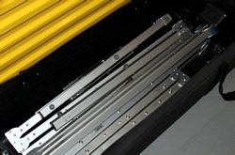 | x1
Shoot Through Umbrellas | 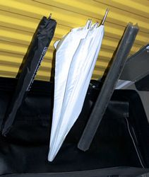 | x1
Calumet 576 LED Panel Light and Flight Case | 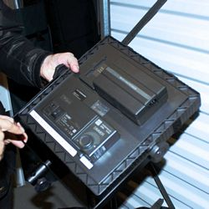 | x1
Canon 24/70 Lens | 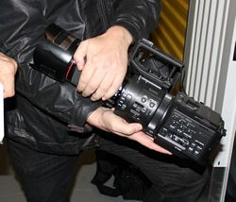 | x1
EVF Zagulo Electronic View Finder | 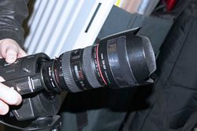 | x1
Peli Cargo Flight Case | 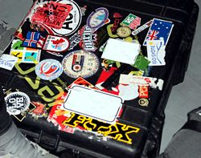 | x1
LEASED ITEM SONY FS700E CAMERA BODY (Settlement as stated on 31/10/13 £ 5724) |  | Leased item not  available
Lowepro Rucksack | 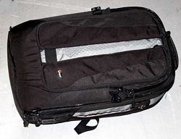 | x1
Lacie Archive Drive 1 TB | 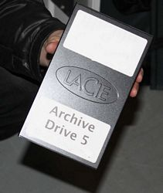 | x6
Peli Cargo Flight Case | 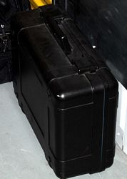 | x2
Profoto 2R Wireless flash Pack | 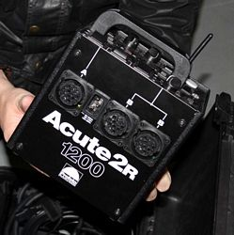 | x1
Profoto Acute D4 Ring Flash | 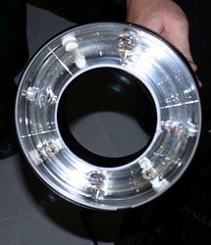 | x1
Pocket Wizard Transceiver | 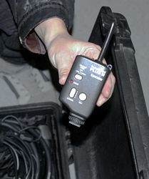 | x1
Calumet Roller Case | 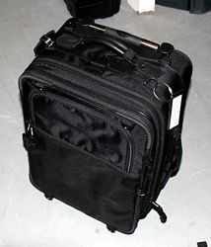 | x2
Manfrotto Carry Case | 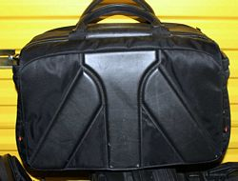 | x1
Kata case of assorted cables
Profoto Speed Rings | 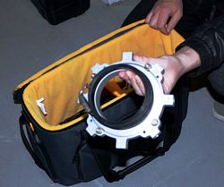 | x4
Profoto D1 500 Air Flash Heads | 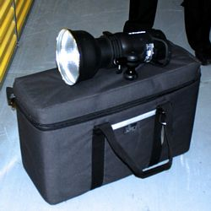 | x6
LG 22" HD Colour Monitors | 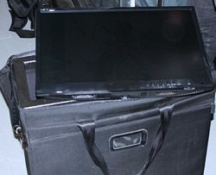 | x2
Temba Flight Case | 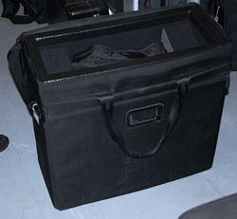 | x1
Peli 1600 Flight Case | 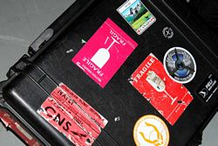 | x1
Sekonic Light Meter | 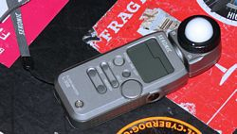 | x1
Box of Assorted Cables, Tapes & Grip |  | x1
Box of Sparkly Background Materials |  | x1
Floor Fan | 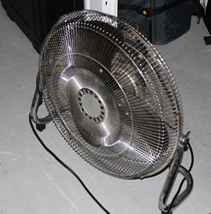 | x1
Billingham Case | 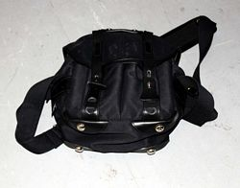 | x1
Lowpro Camera Case | 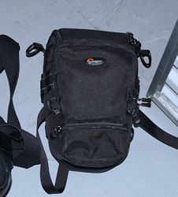 | x1
DGI Phantom R/C Quadcopter Controller, Batteries and Flight Case | 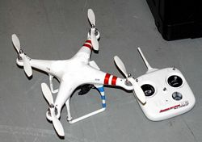 | x1
Peli 1500 Flight case | 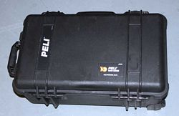 | x1
Red Rock Micro Matt Box | 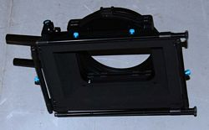 | x1
Switt 7" HD Monitor plus Accessories | 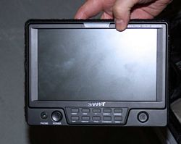 | Leased item not  available
Tascam Audio Receiver | 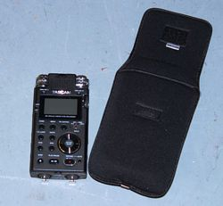 | x1
Peli 1150 Flight Case | 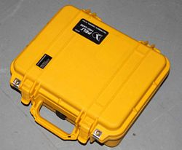 | x1
Peli 1400 Flight Case | 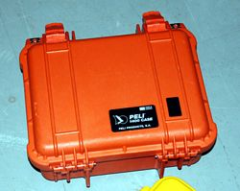 | x2
Merlin Steicam Grip and Case | 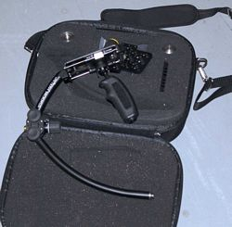 | x1
Manfrotto Dolley | 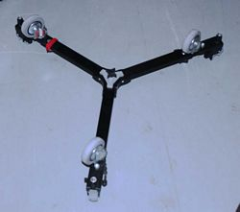 | x1
Lastolite 6Ft x 6Ft White Folding Background plus Case | 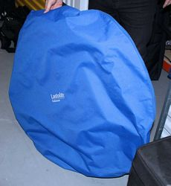 | x1
2Ft circular Beauty Dish | 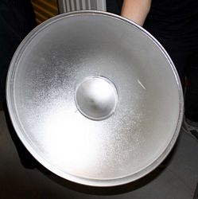 | x1
Lacie rack Mounted server 1 TB 2008 | 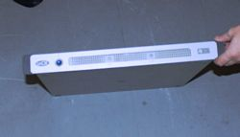 | x1
Lacie 2Big Network Server 2TB | 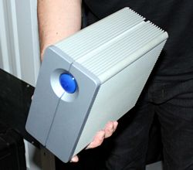 | x1
Topcom walkie Talkie Plus Carry Case | 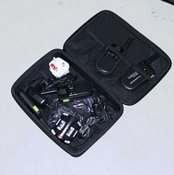 | x2
Lightweight Flight Case | 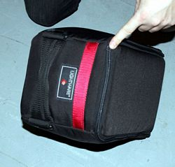 | x1
Embossed Leather Bound Portfolio Case with covers. Branded | 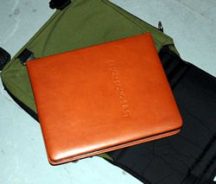 | x12
Samsonite Hand Luggage | 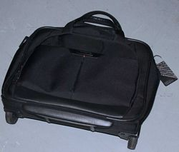 | x1
Glide Track 1 Metre Camera Track | 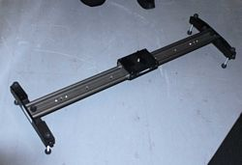 | x1
Low Boy Roller | 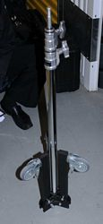 | x1
Red Wing Boom | 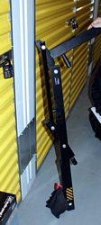 | x1
Heavy Manfrotto Roller | 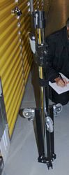 | x1
Cross Boom | 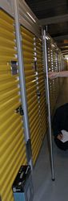 | x1
Manfrotto Tripod 058 Model | 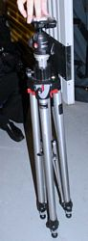 | x1
Assorted Chimera Lighting Strip Soft Boxes plus Flight Cases | 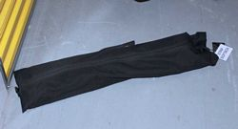 | x1
Assortment of Lighting Gels in Kata Flight Case | 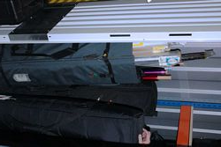 | x1
Monopod Lighting Stands | 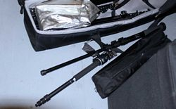 | x1
Medium Lightweight stands plus Case | 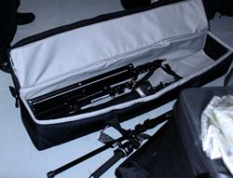 | x1
Manfrotto 190CX Pro 4 Carbon Fibre Very Light Tripod | 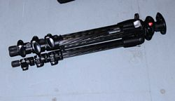 | x1
Micro Californian Sun Bouncers |  | x1
Manfrotto Silver Combo Boom | 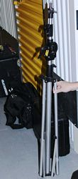 | x1
Tungsten 650 Lights plus Stands and Cases | 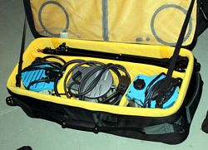 | x1
Pair Numark M80 Speakers | 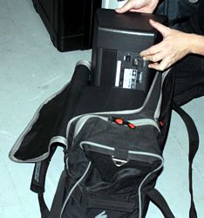 | x1
Lacie 4TB Storage Drive | 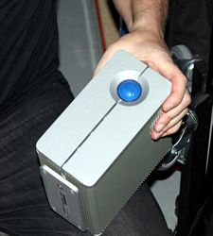 | x1
Drobo 4TB Storage Drive |  | x1
Manfrotto Video Tripod Head | 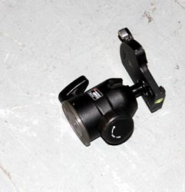 | x2
Box of assorted Drives | 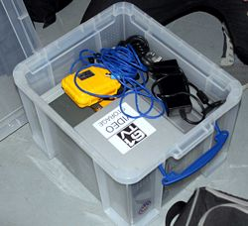 | x1
Hasselblad 100ml Camera Lens serial 7DVS11945 | 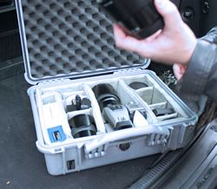 | x1
Hasselblad 80ml Camera Lens serial 7CSR23131 |  | x1
Hasselblad 50ml Camera Lens serial 7BST11764 |  | x1
Hasselblad Camera H3D239 serial 70SR26132 |  | x1
Hasselblad 120ml Camera Lens serial 7EVS16175 |  | x1
Peli 1520 Flight Case |  | x1

