

Amco Agency Limited
Suite 501 International House
223 Regent Street
London
W1B 2QD

Sales Memorandum

The Processing Plant and Offices

Unit 7
Vale Industrial Park
Tolpits Lane
Watford
Hertfordshire
WD18 9RU

2nd December 2009

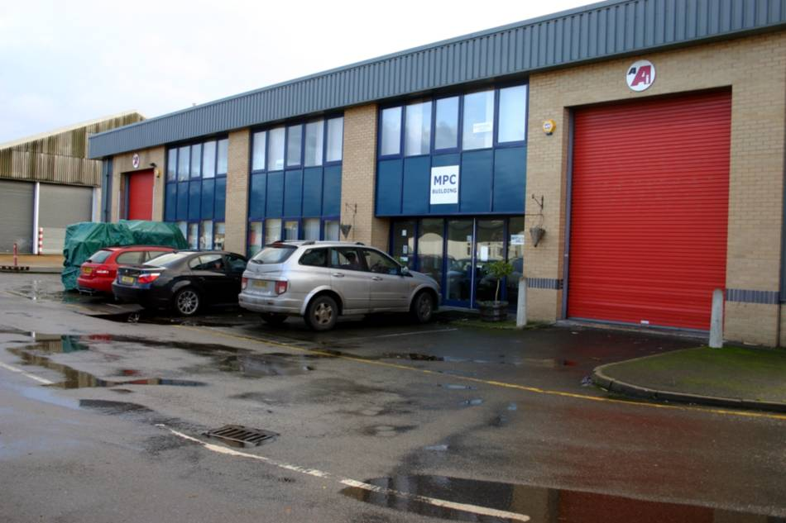
Premises

We offer for sale on behalf of our client a turnkey production unit for the production of Southern Fried and other specialist chicken products.

The facility comprises of a circa 10,000 Sq Ft industrial unit with yard space and associated parking at:-

Unit 7
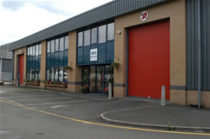
Vale Industrial Park
Tolpits Lane
Watford
Hertfordshire
WD18 9RU
The facility was established during 2002.

The manufacturing unit has separate changing areas for high risk and low risk production areas.

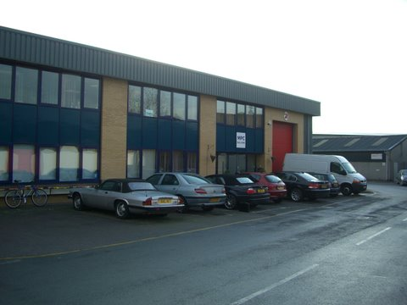
The work flow is arranged around two roller shutter doors at each end.

One for goods in and the other for finished goods.

There are Office and administration facilities on the 1st floor comprising of a large open plan office with two management offices at one end. There is also a separate board room director’s office

There is parking to the front of the building for around 7 cars with further parking to the side and rear of the building.

We understand that there are a further three spaces in the main car park by the entrance to the estate.
Background

Our client, needing a temporary facility whilst consolidating its UK production facilities, acquired the premises in 2008 from Maryland Poultry Ltd.

The facility was already well equipped and was producing Chicken Products for the general market and Meal Products for airline catering.
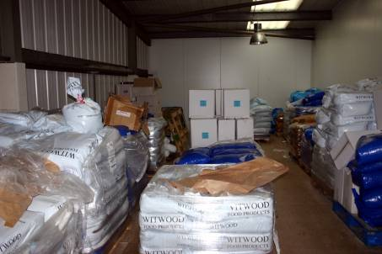
Improvements

Since acquiring the premises our client has constructed a mezzanine floor above the “Goods In” area for dry goods storage. This has been complimented by a large freezer area below.

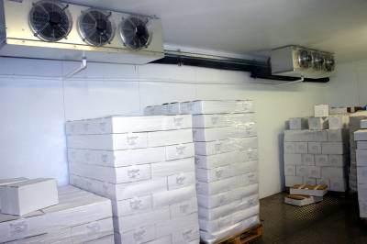
The mezzanine is serviced by a steel staircase and has a safety cage for loading to forklift trucks.

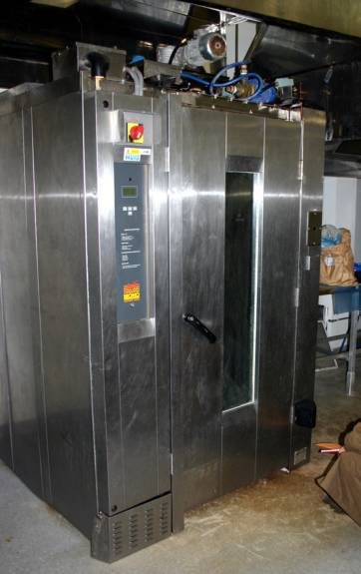
Our client has also introduced a schnitzel press and breading machine.

There is an additional oven on site that has not been commissioned.

Our client no longer needs the use of these premises having successfully completed the production move and is offering the plant as a “Turnkey Operation”.

Our client is prepared to consider offers that exclude some of the fittings and fixtures where a differing food production is envisaged.
Lease Details

Our client negotiated a new 5 year lease from the landlord which commenced on the 18th of July 2008.
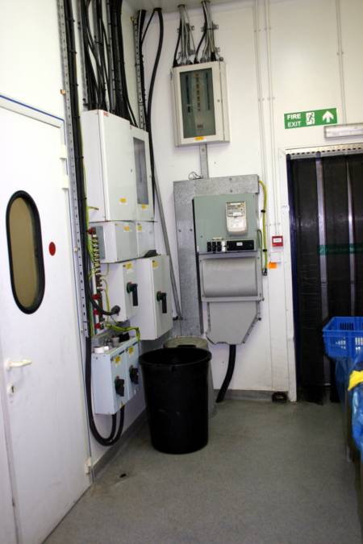
The current lease is valid till 17th July 2013.

As is usual it is a fully repairing lease.

The current Rental is £65,000 per annum.

Rates are stated by our client to be £25k per annum. Buyers are advised to verify this figure for themselves

Our client has the option to determine the lease at the two year term if required.

There is a Gas supply to the premises along with a substantial electrical feed. We are advised that there is spare capacity on both.

The building has a both a burglar alarm and fully functioning fire warning system with an audible alarm and “Red Care”.

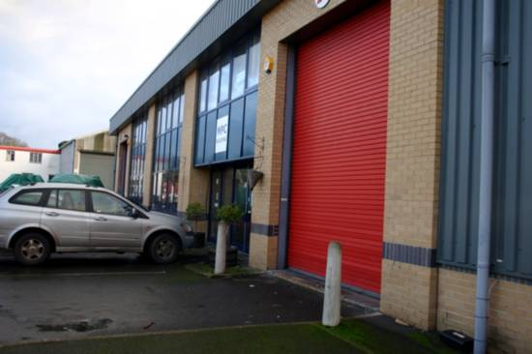
As advised earlier there is parking to the front of the building for around 7 cars with further communal parking to the side and rear of the building. We understand that there are a further three allocated spaces in the main car park by the entrance to the estate.

Visually the premises appear to be in good order however a purchaser should make his own detailed assessment prior to proceeding.

Our client’s relationship with the landlord is very good and there are no issues arising from their use of the premises.

No enforcement notices have been issued and we are not aware of any complaints pending.
Location

Watford is ideally situated close to the M25 and M1 Motorways with easy access to Heathrow and the Motorway network in general. Access to Central, East, West, North and South London is very good as is access to all of the London Airports.

Going further the direct links to the Motorway Network means that Birmingham is just 1Hour 46 Minutes away, Oxford 59 Minutes and Bristol just 1 hour and 58 minutes.

As an indication Satellite Navigation Travelling times from Tolpits Lane are calculated as:-

46 Minutes or 21 Miles to Central London W1
32 Minutes or 19 Miles to Terminal 1 London Heathrow Airport
33 Minutes or 18 Miles to Wembley Stadium
33 Minutes or 20 Miles to London Luton Airport
60 Minutes or 45 Miles to London City Airport and Docklands
55 Minutes or 24 Miles to the Olympic Stadium in Stratford
56 Minutes or 46 miles to London Stanstead Airport
66 Minutes or 56 Miles to London Gatwick Airport

Birds Eye View of the facility

West View http://www.multimap.com/s/BJiZUHMz

South View http://www.multimap.com/s/DLiZcaeS

East View http://www.multimap.com/s/BNmWXYgU

North View http://www.multimap.com/s/CKjXUHHC

Aerial View http://www.multimap.com/s/gpb8cA25

Map of the Vale Industrial Estate

Workflow Diagram

A scalable version is available at www.a406.com\tolpits\plans\flow.pdf
Floor plan

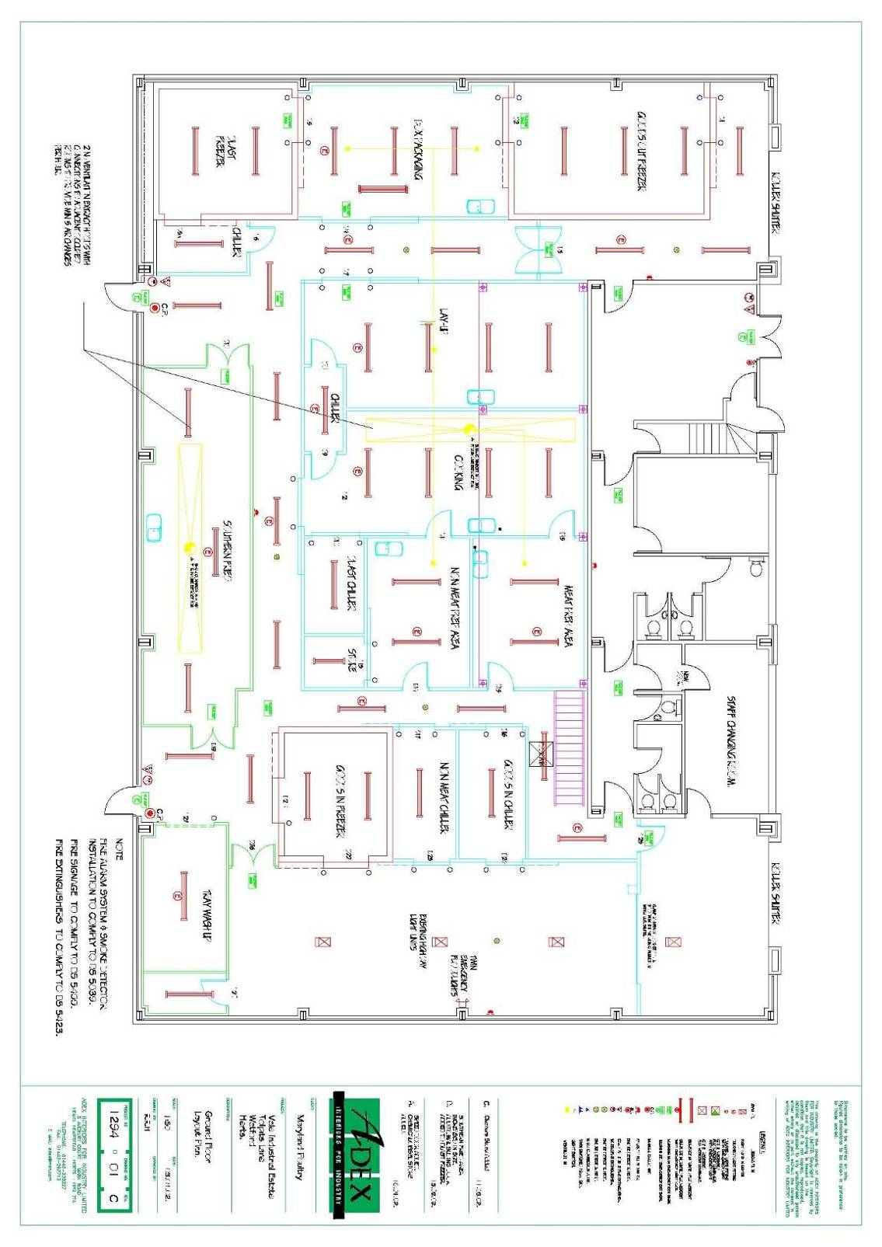
This is the original floor plan document from 2002 prior to the mezzanine floor and freezer installation. Other modifications may also have been made. A scalable version is available at www.a406.com\tolpits\plans\floor.pdf
The Food Standards Agency approvals for the premises have recently been upgraded. The original approval “cutting plant for the production of poultry meat” and “processing establishment for the manufacture of meat products” is now as shown below.

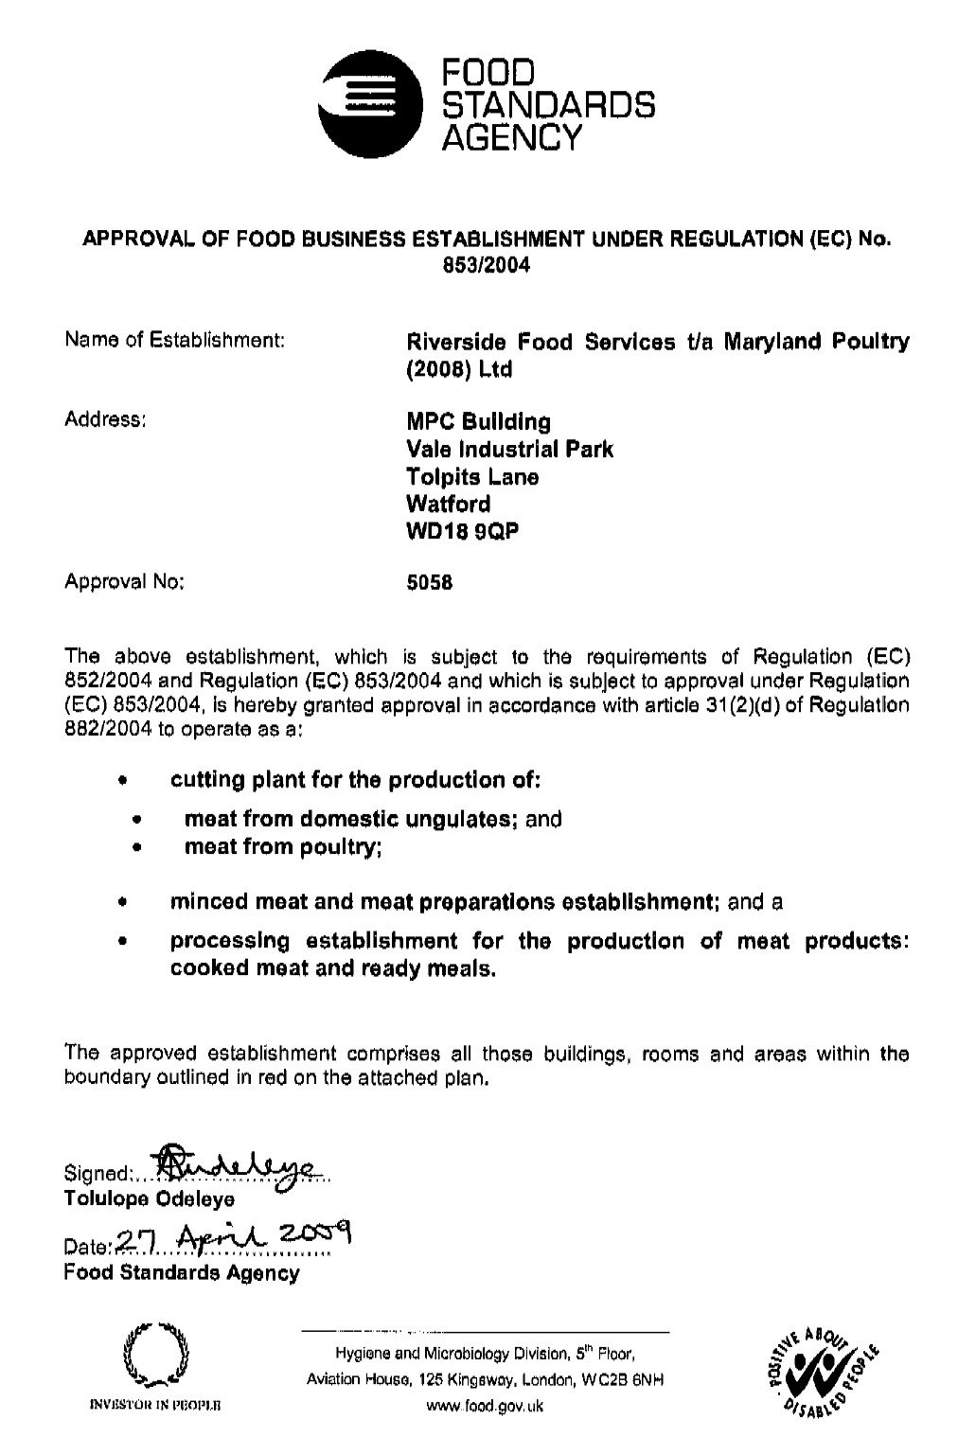
Production and Distribution Staff.

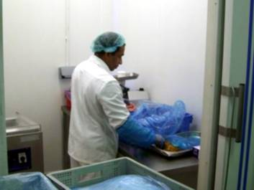
There are no employees remaining at the facility.

We understand from that all TUPE liabilities have been discharged by our client and the previous employees.

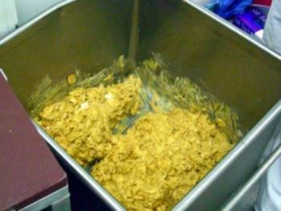
The long serving (14 Years total) factory supervisor has been retained, on a part time basis to manage the empty premises until sold.

There is an opportunity to re-employ the supervisor who we understand would come recommended by our client. His current employment term is just over one year.

Typical weekly wage rates paid to production staff in 2008 were:-

Function | Wage
Supervisor | £ --.--
Processor Raw | £ 244.70
Chicken Cutter | £ 296.00
General Cook | £ 465.00
Chicken Cutter | £ 413.00
Fried Chicken M/C | £ 253.74
Flow Wrapper | £ 281.52
Processor Raw | £ 231.84
Cleaning | £ 303.60
Sandwich Processor | £ 239.08
Meals Processor | £ 251.16
Meals Processor | £ 238.74
Processor | £ 256.68
Flow Wrapper | £ 238.74
Food processor | £ 223.56
Processor Cook | £ 250.80
All Rounder | £ 238.74
SFC Machine | £ 220.80
Salads | £ 325.68
Driver | £ 465.02
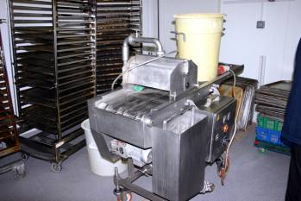
Plant and Equipment

The following Plant and Equipment is present and included in the sale.

1 x Fryer 2002, cost 27K
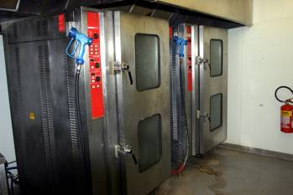
1 x Minitfjord Chiller 2002, cost 10K
1 x HK Blast Freezer 2002, cost 4K
1 x Teknomek S/S fittings 2002, cost 7K
2 x Convotherm Ovens
1 x Freezer MAB36A/C45E7 2002, cost 2K
1 x Chillier M1F10ADP 2002, cost 24K
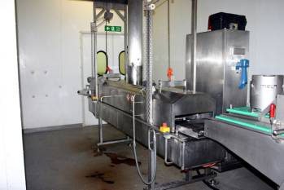
1 x Chillier MEGINI50A/C029D 2002, cost 10K
1 x Chillers M1F25ADP/M1F10ADP (Fermond Freezer) 2002,cost 38K
1 x Maneurop Condensers etc 2005 to July 2008, cost 11K
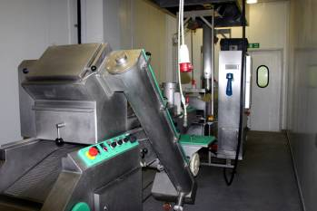
1 x Maneurop Condensers etc 2007 to April 2010, cost 11K
1 x Hermikit Compressor etc 2002, cost 30K
1 x Chillier MABP70A/T1056.0 2002, COST 27K
2 x Minifjord Chiller 2002, cost 34K
1 x Minifjord Chiller MABP55A/T784b 2002, COST 13k
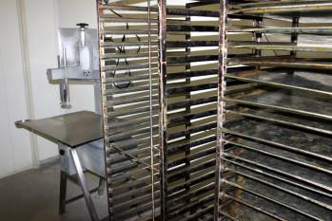
1 x Chiller MAP55A/T78 &Blast Chiller MEGP100A/C208D 2002, cost 65K
1 x Meyn Pre-Duster MPD400 & Batterer BU400 2002, cost 33K
1 x Refrigeration MAB36A/C45E7 2002, cost 33K

1 x Schnitzel press and breading machine
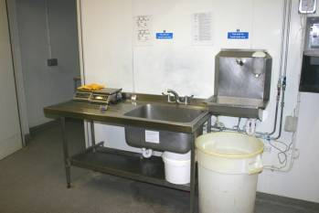
1 x Mezzanine Floor with Safety Cage and steel staircase.
1 x “Goods In” Freezer Walk through

There are also a number of incidental sundry items including knives, trays and other production equipment as seen and inspected by buyer.

Also available by separate negotiation

1 x Mitsubishi Forklift 2002, cost 4K
1 x Nissan Forklift 2002, cost 7k
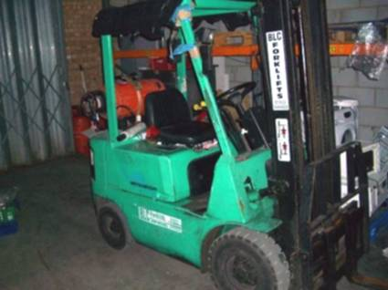
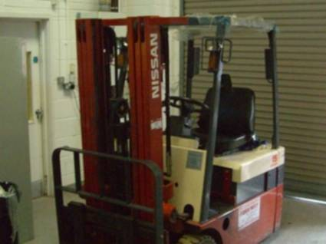
Contact
Michael Charles
Amco Agency
International House
Suite 501,
223 Regent Street,
London W1B 2QD

Tel: + 44 (0) 8452 300700
Fax: + 44 (0) 8703 501232

Notes

In preparing this summary we have relied upon information provided by others including officers and employees of the Company.

We have proceeded on the basis that where such information has been provided it is accurate and that there has been full disclosure of all material facts.

This document is not designed to be a substitute for “due diligence” it is offered without warranty of any kind and could contain errors or omissions.

This document is private and confidential and shall not be disclosed to any third party without our prior written consent.

Neither the whole, nor any part of this document nor any reference thereto, may be included in any published document, circular or statement, nor published in any way without our written approval of the form and context in which it will appear.

Misrepresentation Act 1967 - Although all the information in these particulars is believed to be
correct neither the agents nor their clients guarantee its accuracy nor is it intended to form part of
any contract. All areas quoted are approximate.

Finance Act 1989 - Unless otherwise stated, all prices and rents are quoted are exclusive of Value
Added Tax (V.A.T). Any intending purchasers or lessees must satisfy themselves independently as
to the incidence of V.A.T. in respect of any transactions.

Amco agency themselves and for their vendors and other clients of this property, whose agent they are have taken all steps reasonable to ensure the accuracy of these particulars, although they accept no responsibility for errors, nor can any claim be entertained for any inconvenience, expense or other costs, caused by any reason of the withdrawal of the particulars of the property from the market.

Prospective purchasers or tenants are strongly advised to seek professional advise from a professional qualified surveyor and solicitors and to make their own enquiries, as to whether the property is suitable for the use that they require it and the apparatus, fixtures and fittings, included in the contract are both working and fit for purpose.

Each party is required to pay its own legal and other advisors fees.

Amco Agency

